

Final Year Project Proposal

BEng in Software and Electronic Engineering
Student Name: Paulina Osikoya
Student Number: G00348898
Supervisor: Brian O’ Shea
Project Engineering
Year: 4

Project Title

IOT Smart Home Automation System

Hestia



Project Title: IOT Smart Home Automation System

Introduction
Automation is becoming an increasingly massive section and hot topic in today’s IOT sector. From the automation of arduous long complex installations using basic scripts to automating our day today tasks by simply implementing a mechanism that notifies you of your daily tasks to be executed during your set out schedule.
During my Internship my role was centralized around automation and design of software to achieve and reach levels of performance that the world has never witnessed before.
I wish to implement similar into my Final Year Project (FYP).

Project Description

My Final year project is an internet of things (IOT) home automation system. The name of my home automation system is called Hestia. The name is derived from Ancient Greek religion, she was the goddess of ordering of domesticity, the family, and the home hence why I thought the name was befitting for my FYP.

My FYP will be developed and deployed on two microcontrollers which will be then implemented into a house model designed and created by me and finally integrated with a website and application hosted on Docker Container Framework using the Orchestration system Kubernetes.

Project Functionality

My FYP possesses both a creative and technical aspect.

For my project, the development platforms that will be working are the Esp32 and Raspberry pi 3, I will also be creating an interactive website and a mobile application that will display the functionality and simulations of my FYP. The website will be created by using the following languages HTML, CSS, Bootstrap, Golang and JavaScript. The Container Technology Orchestration framework Kubernetes(K8s) will be implemented into both the app and website. The benefits to this are user scaling control, lower latency and performance. Both the website and the app will connect to the Wi-Fi module already integrated on the esp32.
My Home automation system will be written in following languages: C++, C and Python. I will use technologies such as GitHub and git to commit my code to and online repository that I have created for the purpose of my FYP. With my IOT Home automation system, the user will be able to successfully use voice commands that will be picked up by an Alexa to execute specific functions inside the house. The benefits and use cases it will yield will be the following:
- Eliminates the possibility of a burglary happenig
- Delivery Service such as DHL, FedEx no longer have to wait for the owner to be at the house as the user will be able to connect to the delivery man via the video stream mechanism implemented in the house.
- Ease for the Customer - customer can lock their door or check the status of their door while not being present at the house.
- The user can control the usage of appliances within their home via the app or website
- Integrated system for the user ( aware of the day ahead of them)
- Fire aware and proof Smoke sensor will alert the Solenoid values to release water to stop a fire from happening
All my hardware elements, digital inputs and outputs and analog inputs (i.e. the green led, the on / off switches and the various sensors ) will be connected to both the esp32 and the Raspberry pi 3, which will execute the preprogrammed algorithms I will write for the functionality of my project. The following Headings bellow explain the Mechanism andthe functionality it brings to the IOT Home:

Sensor:
In my FYP , many sensors are implemented such as proximity , servo motors, humidity , temperature sensor (temp regulation), solenoid valve (for water dissipation), Speaker: 0.25W, 8 ohms, buzzer and potentiometer sensors. The function of these sensors are to track temperature, open and close doors, windows, gate and garage door, serves as alarm system and also for water dissipation of water in the case of fire and hypothetically water grass and flower if it was a Lifesize house.

Alexa:
Serves a central component that listen for voice commands and executed function by sensors within the house

I2S:
Is the technology that will be used to integrate the Alexa with the esp32 microcontroller.

IP Camera:
Serves a central component that streams video to the website and both app if the user/ home owner is not presently at the house and also integrates machine learning to scan for faces and number plates that are familiar to the house. Will be developed on the raspberry pi 3

OpenCV:
Is the software that will be for the machine learning and facial recognition

I2C:learn.sparkfun.com
I2C is the serial protocol that will be used for the communication between the esp32 and the pi 3
Bluetooth:
Is the technology that will be used for communication between the IOT Home system and the mobile

K8s platform (website and Mobile Application):
The Container Technology Orchestration framework Kubernetes(K8s) will be implemented into both the app and website. The benefits to this are user scaling control, lower latency and performance

[ See appendix A]

House Model Architectural Diagram
Below the diagram shows a visual representation of my FYP House Model that I design and created myself.

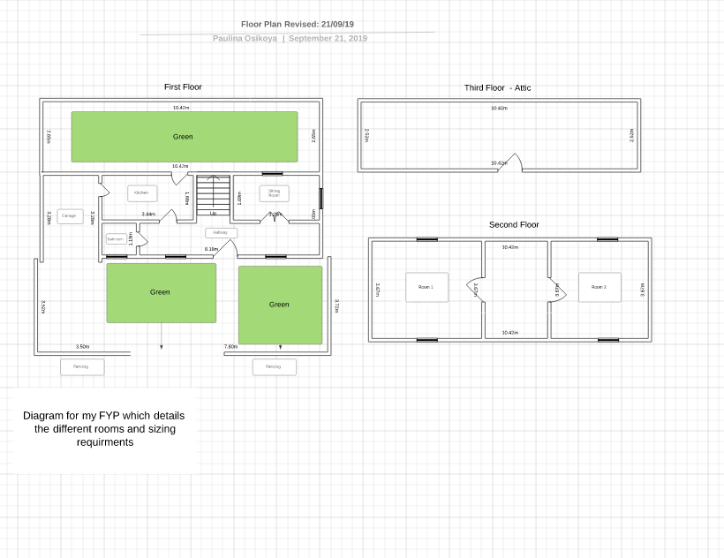

Block Diagram Diagram
Below the diagram shows how my FYP is wired and the inputs and outputs in the project

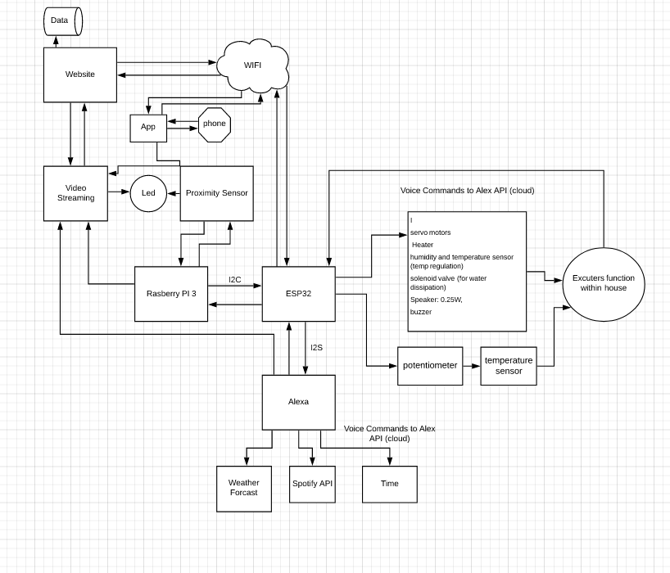

Block diagram explanation

Appendix A B

Appendix B B
Flowcharts
Below are various flowcharts that i created to show how each of the sensors that i will implement into my FYP with work with the various features that i have alluded to.

Alexa:

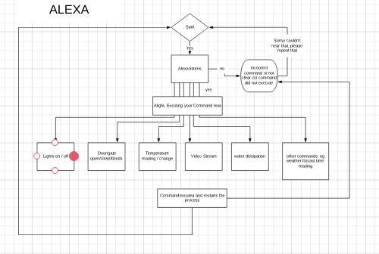

Proximity:

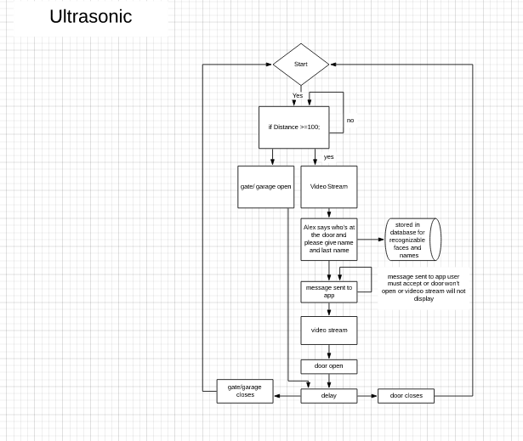

Website\App:

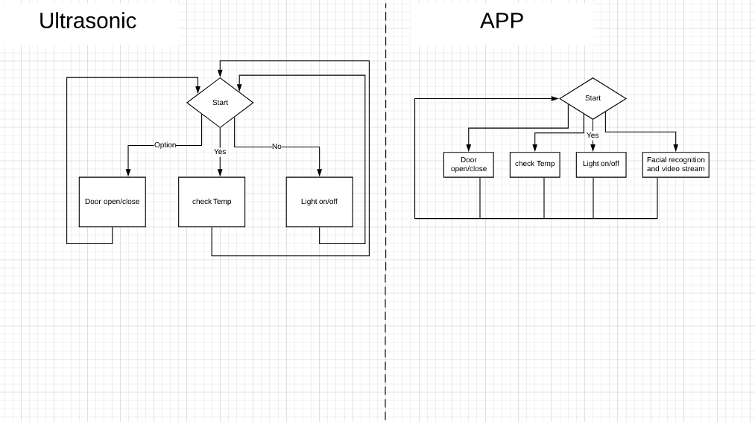

Architectural Diagram
Below the diagram shows a visual representation of my FYP clearly detailing the wiring.

Appendix B A

BOM

Hardware requirements
- An IP camera (video streaming)
- servo motors x 6
- Proximity (ultrasonic sensor) sensor x 2
- lightbulb as a heat source (heater i the model house)
- humidity and temperature sensor (temp regulation)
- solenoid valve (for water dissipation)
- Speaker: 0.25W, 8 ohms
- buzzer
- potentiometer
- 5v and 12v battery power supplies
Software programming languages
- C++ (multi-threading)
- C
- Python
- Go

Website development Coding Languages:
- Html
- CSS
JavaScript
- Bootstrap

Appendix C A

Other technologies used within the project:
- Container framework such as Kubernetes for website and application
- I2C – communication between esp32and raspberry pi
- I2S – integrating Alexa
- Open cv –facial recognition
- Android app development
- Git – for code version control
- GitHub
- PCB design
- Android App Development
- Architectural BIM design
- Agile Project management
- Bluetooth
- GSM text notifications
- Lucid chart
- Fritzing
- Machine learning
- Revit BIM Archectural model
- AutoCAD Architecture
- AutoCAD – for model design

Appendix D A
BOM for Hose model
Mat
Skewer sticks (15 packs 20 packs 40e)20 times smalller than the actual house
1:10
1:20
1:100 is too small
Grey card

Date:18/09/19

Dafont
Canva.com
Github
Kuberntese.io

Architecture Diagram

Appendix:

